**ASSIGNMENT-3**

**MODULE 8**

**CLOUDFORMATION**

**DONE BY  
RANJITH KUMAR**

**Tasks To Be Performed:**

1. Use the template from CloudFormation task 1.

2. Add Notification to the CloudFormation stack using SNS so that you get a

notification via mail for every step of the stack creation process.

STEP 1 : Open Cloudformation from aws services

STEP 2 : Use the S3 creation template from task 1

STEP 3 : Give name to the stack and in notification options select the SNS topic(Creation of sns topic mentioned at the last)

STEP 4 : Stack have been created

STEP 5 : Creation of stack have been notified to the email address

**Creating a SNS topic:**

STEP 6 : Open SNS from aws services

STEP 7 : Select create topic

STEP 8 : Select standard type , give name to the topic and necessary information needed to create a topic

STEP 9 :SNS topic has been created

STEP 10 : Select the topic and go to the subscriptions > Create subscription

STEP 11 : Select the protocol as email and create the subscription

STEP 12 : Confirmation for the subscription will be received in the email.Confirm the subscription

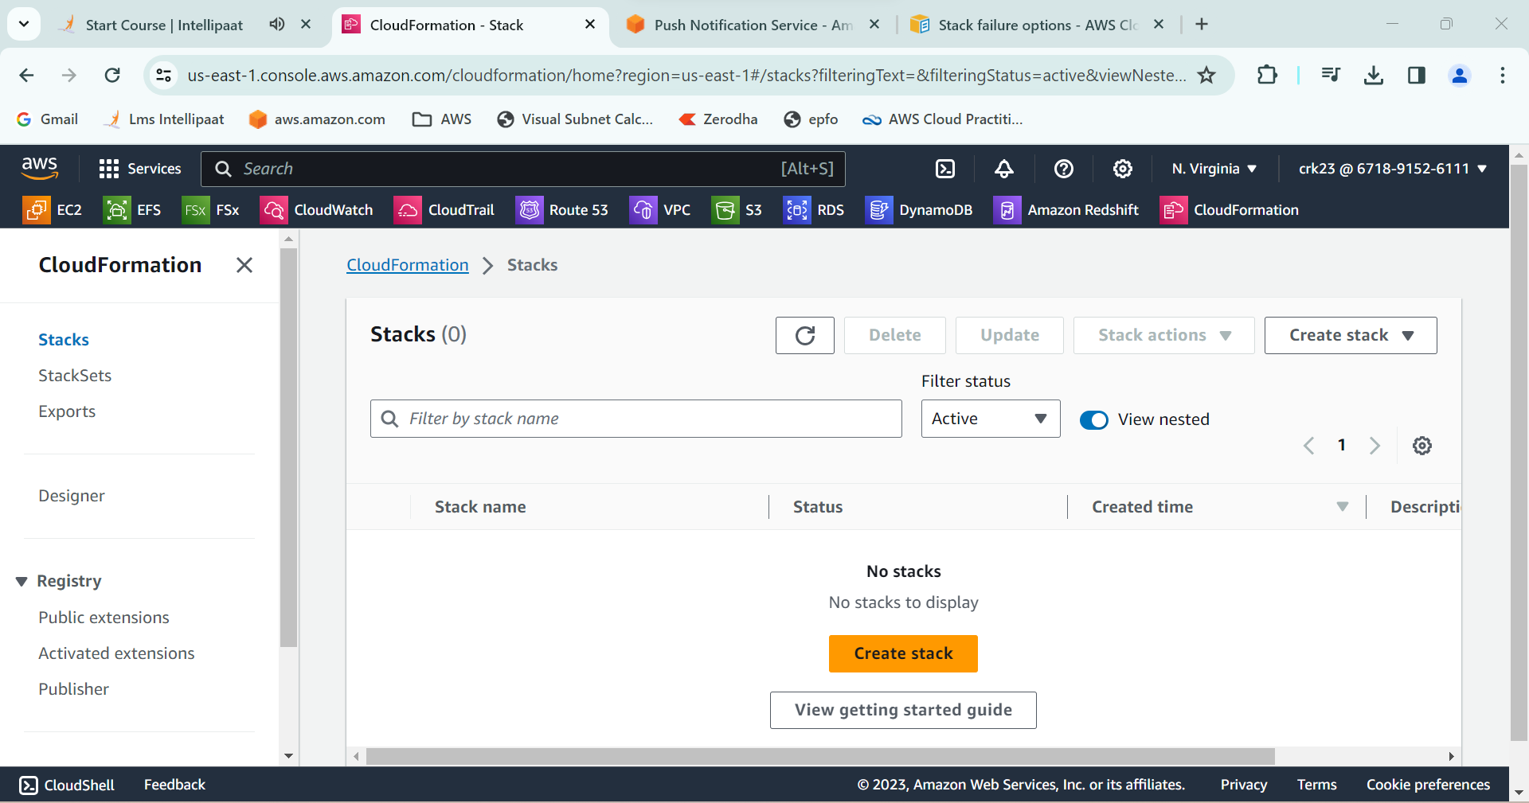

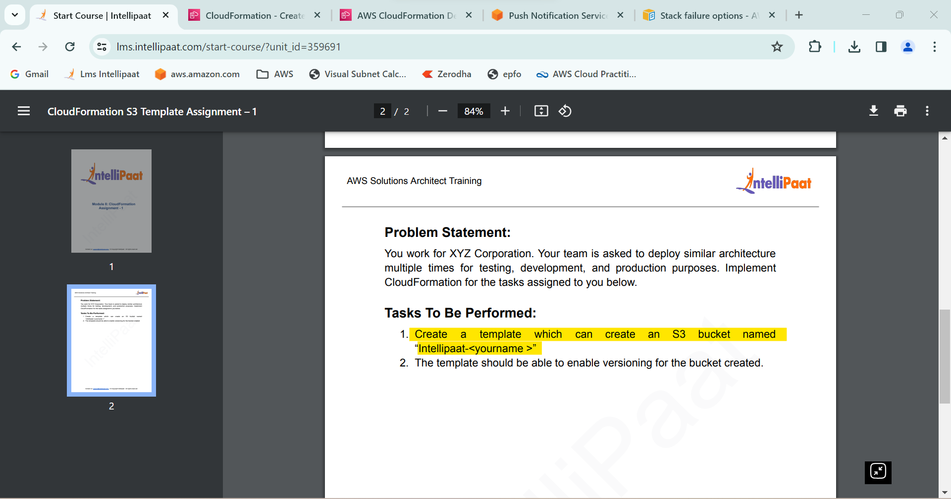

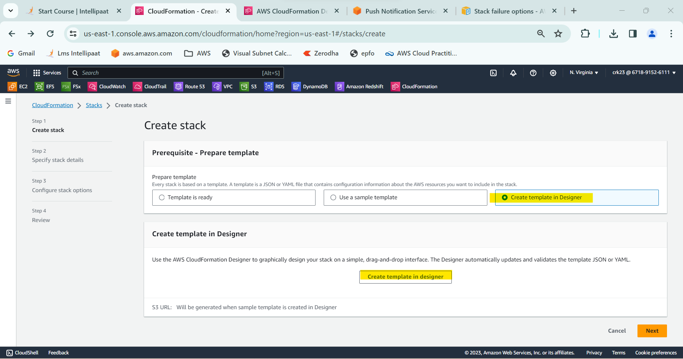

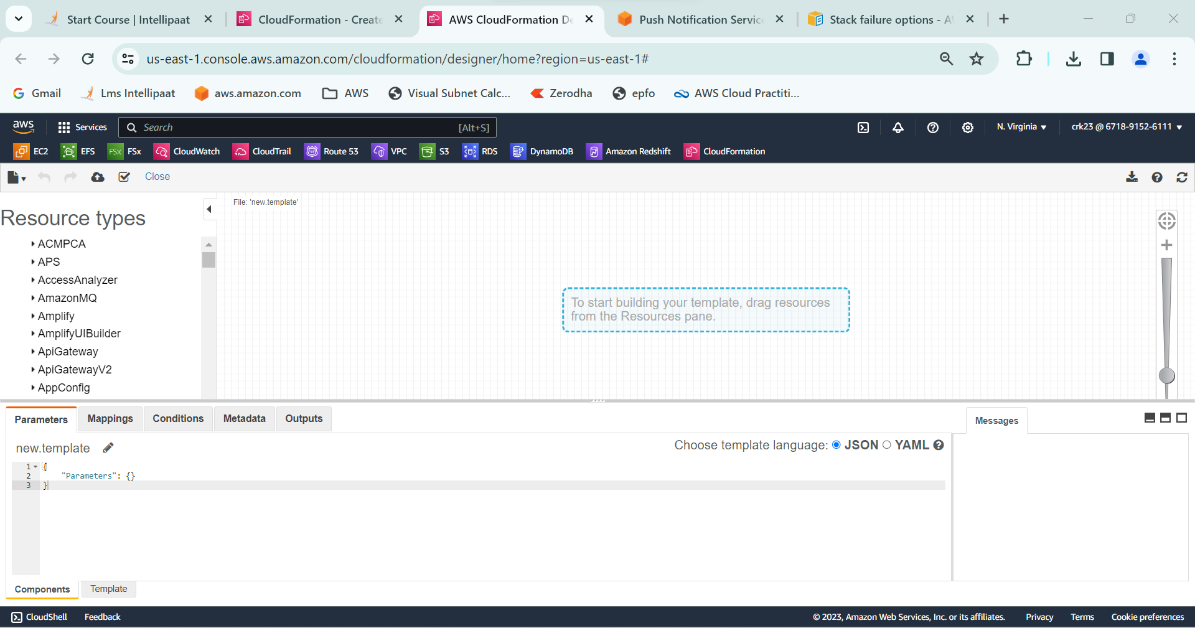

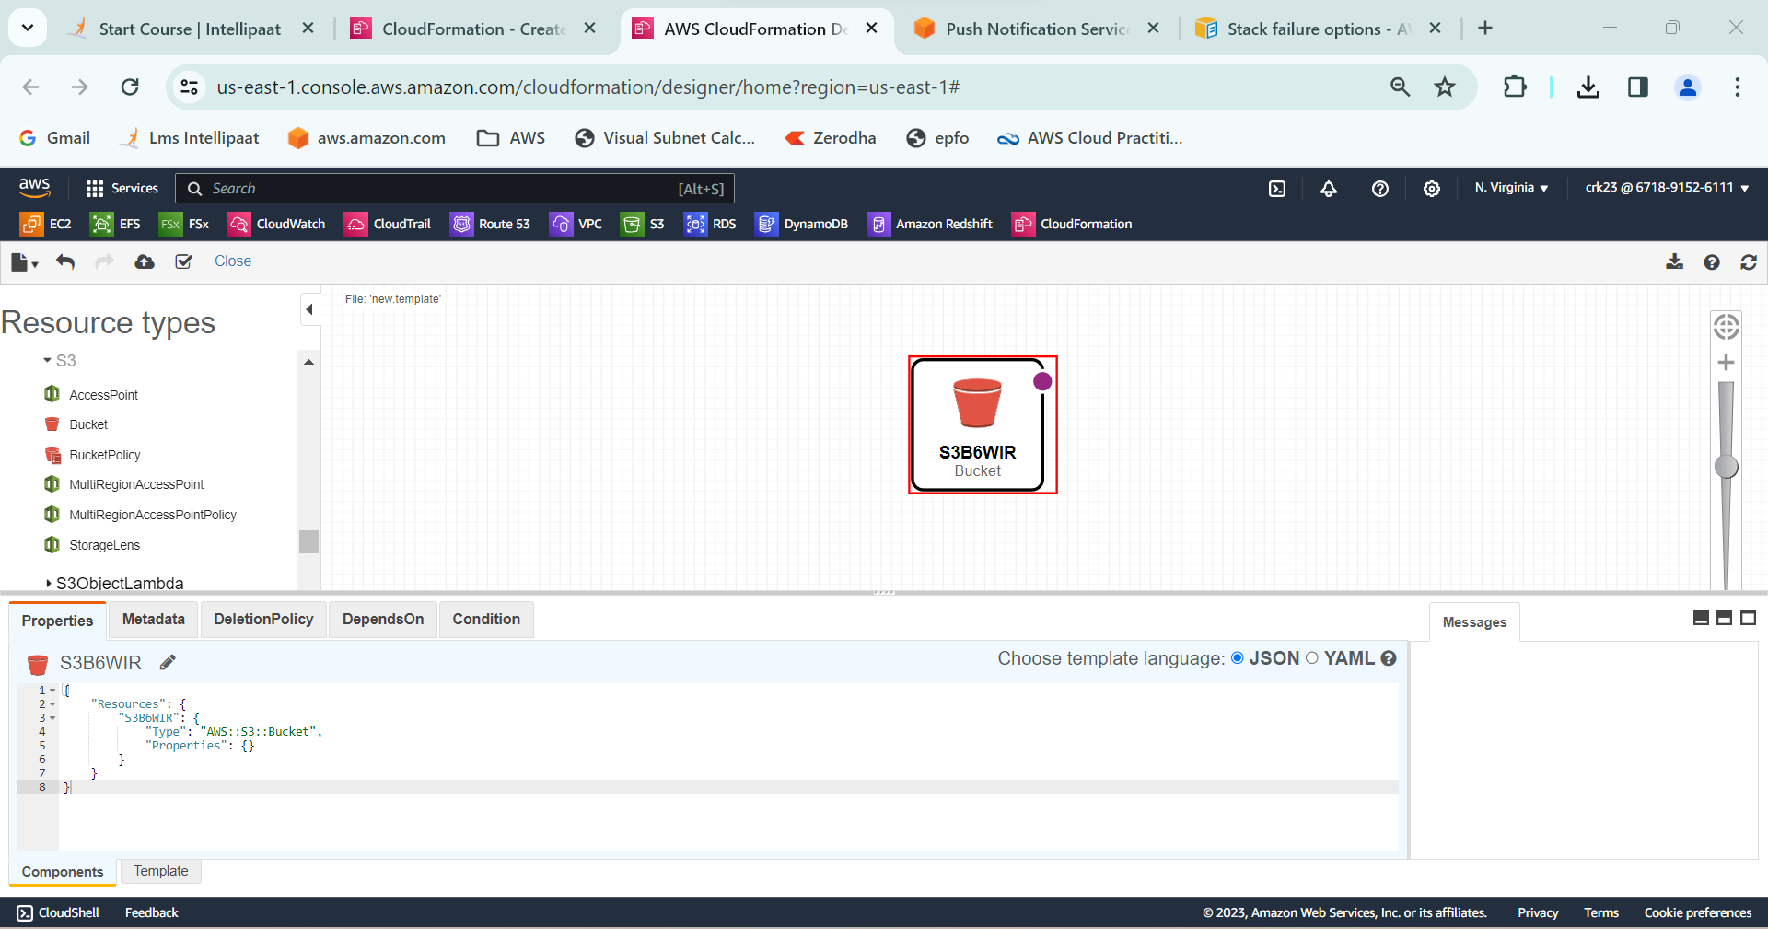

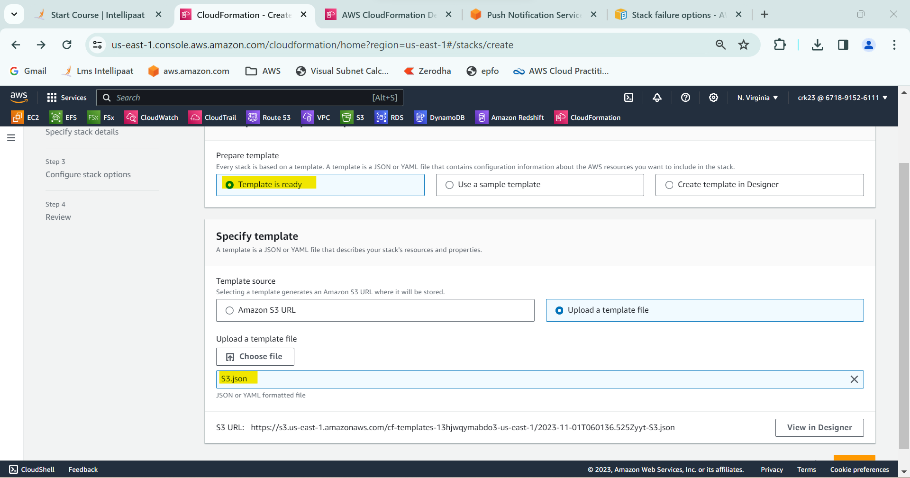

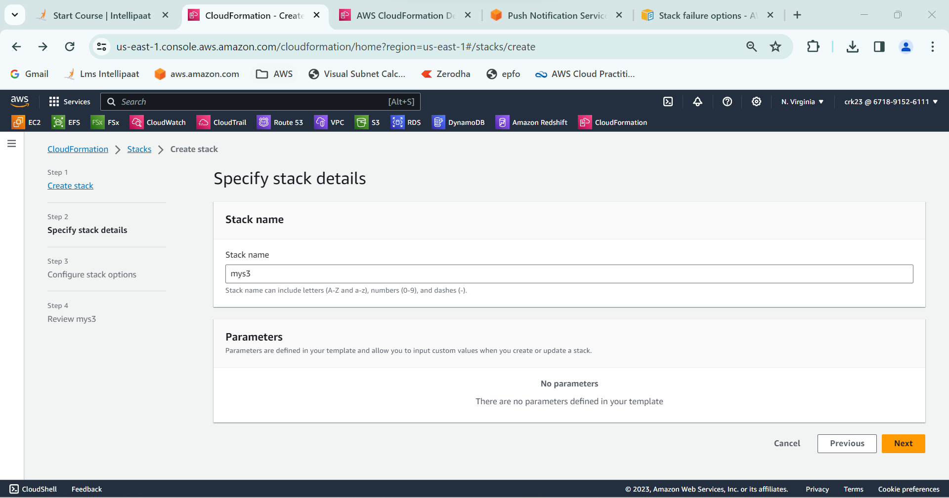

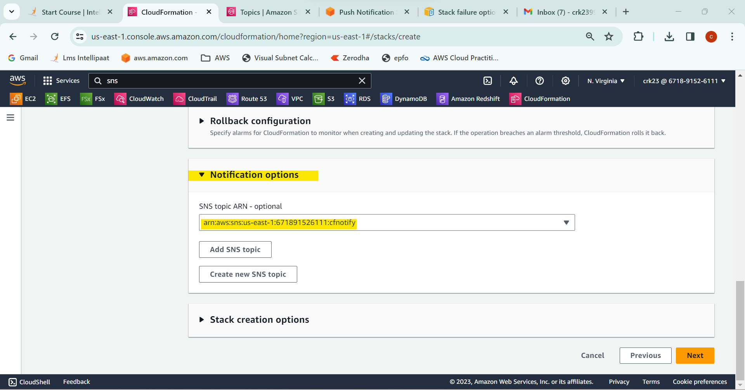

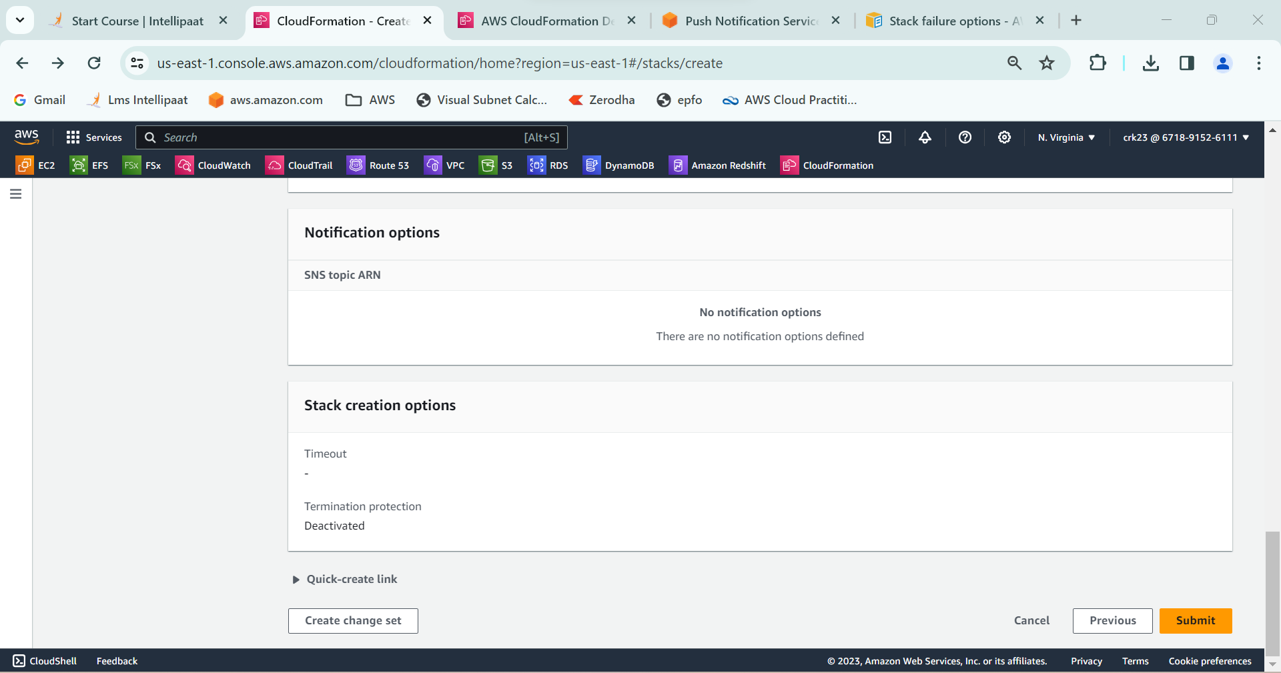

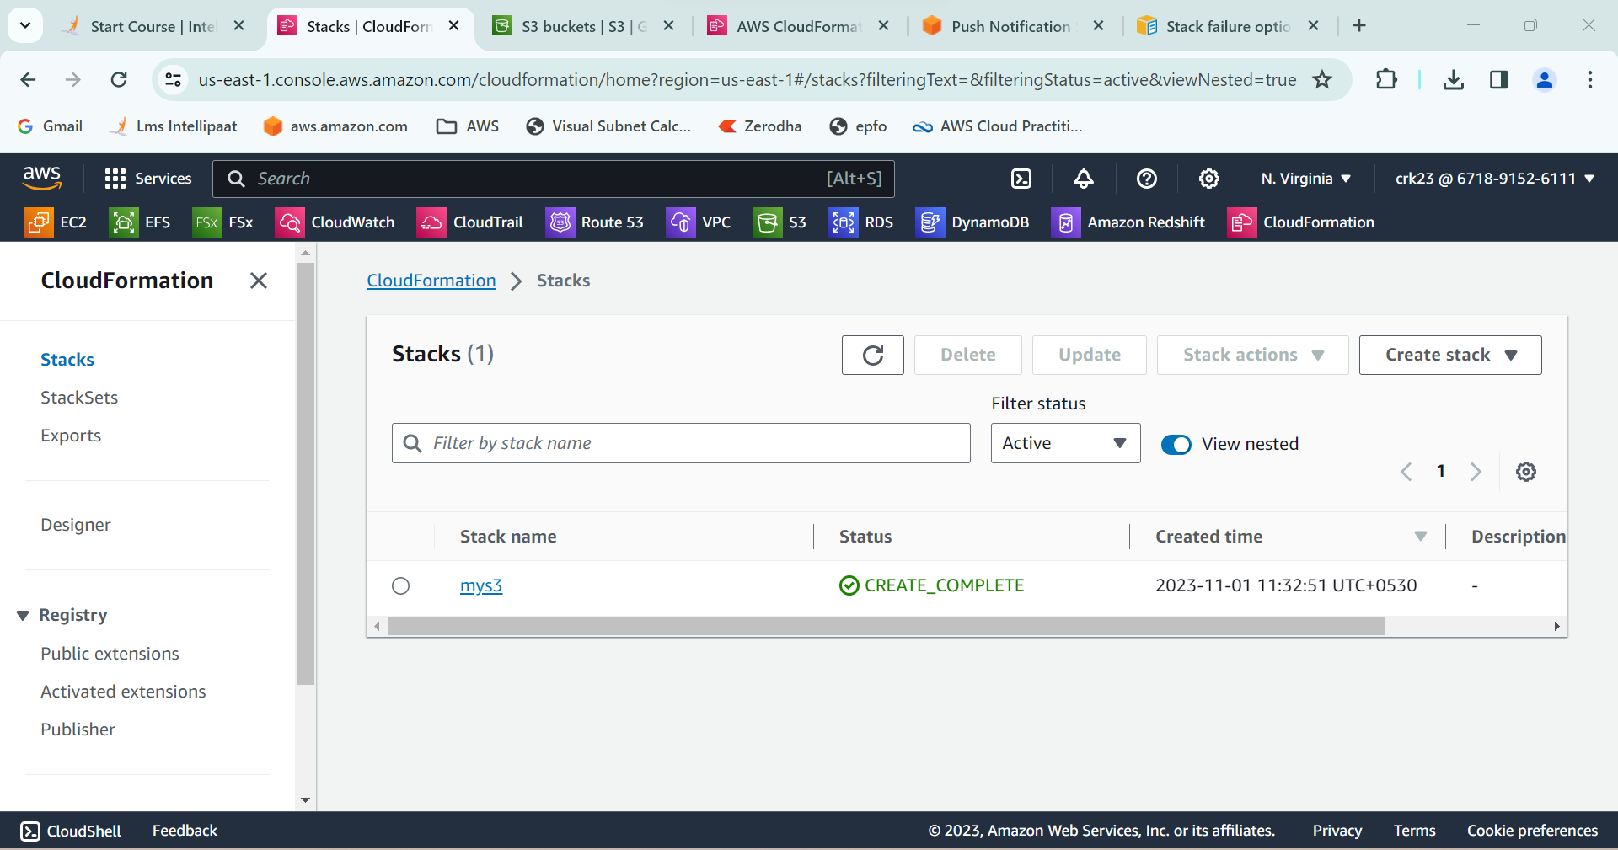

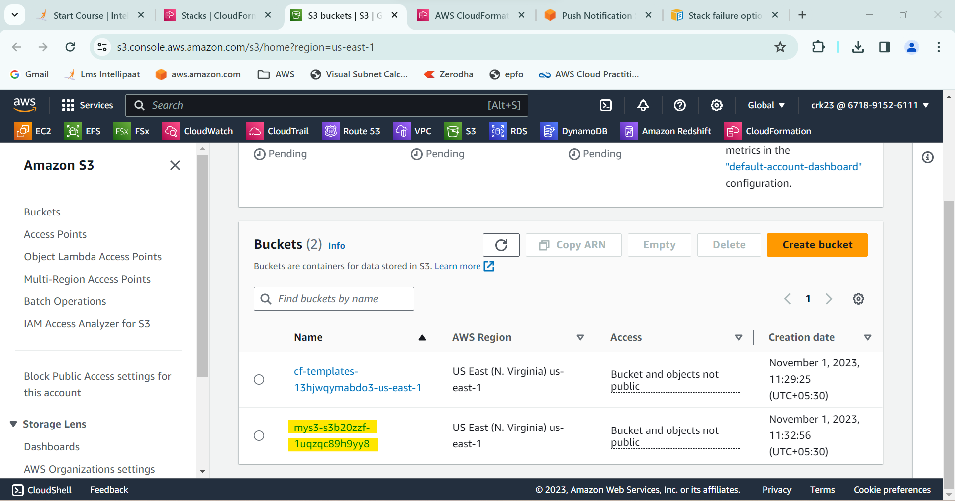

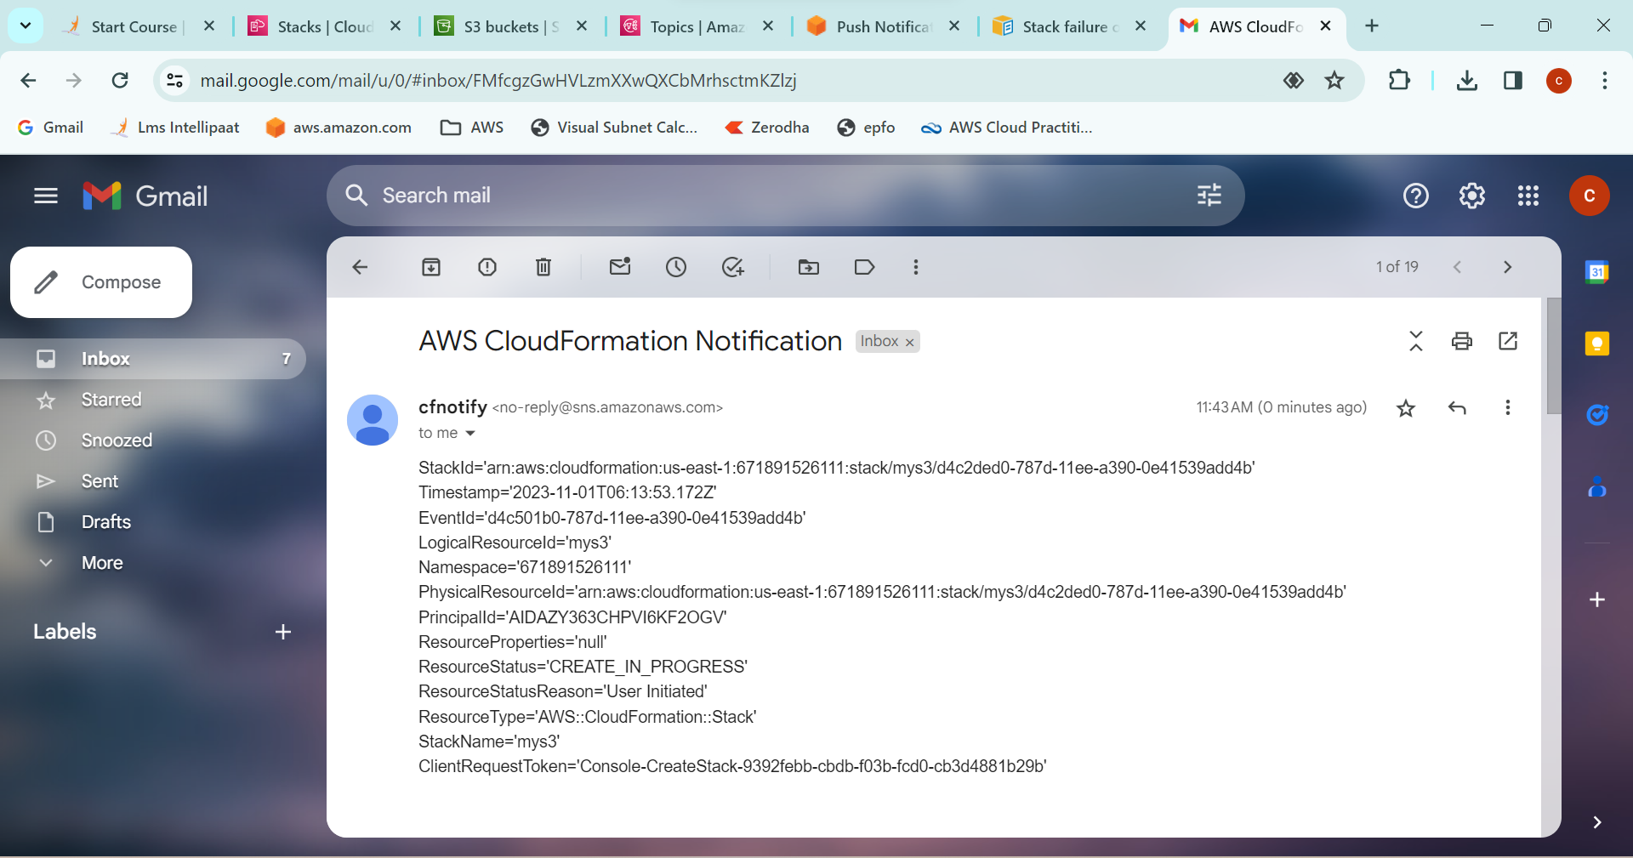

**Creating a SNS topic :-**

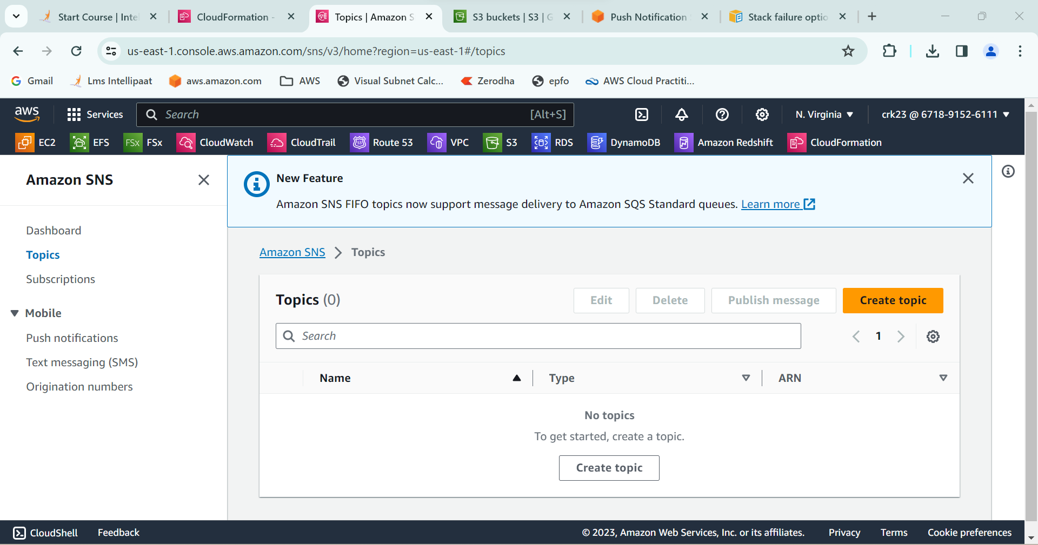

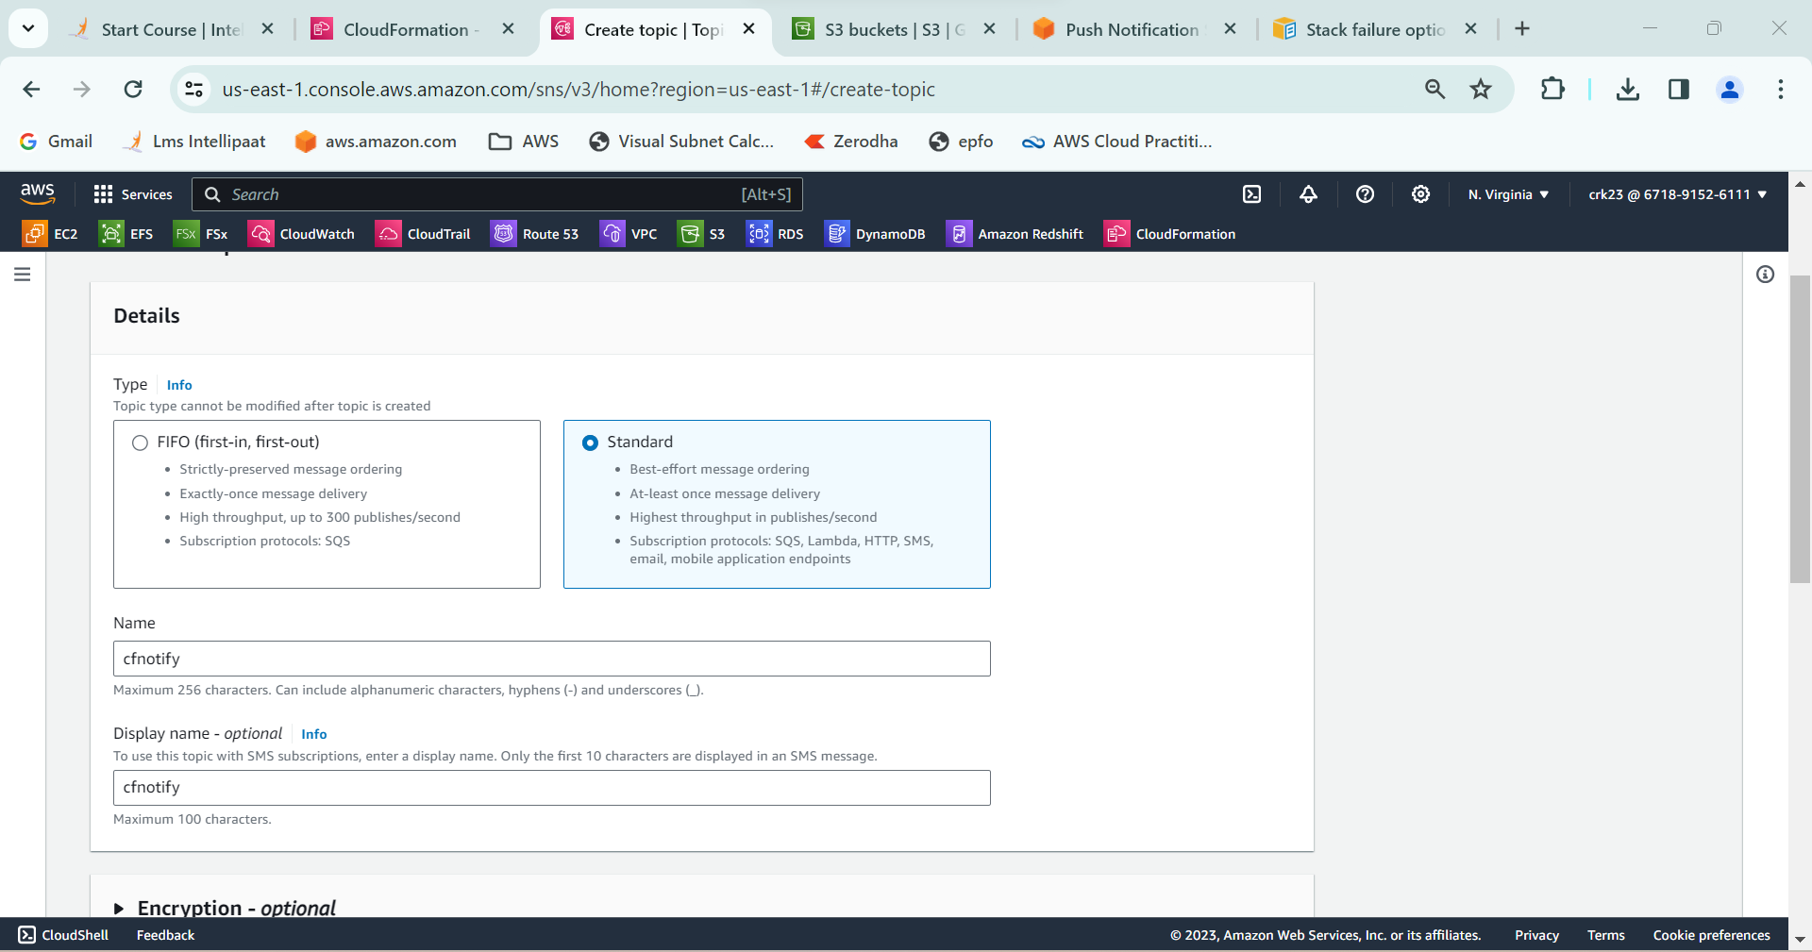

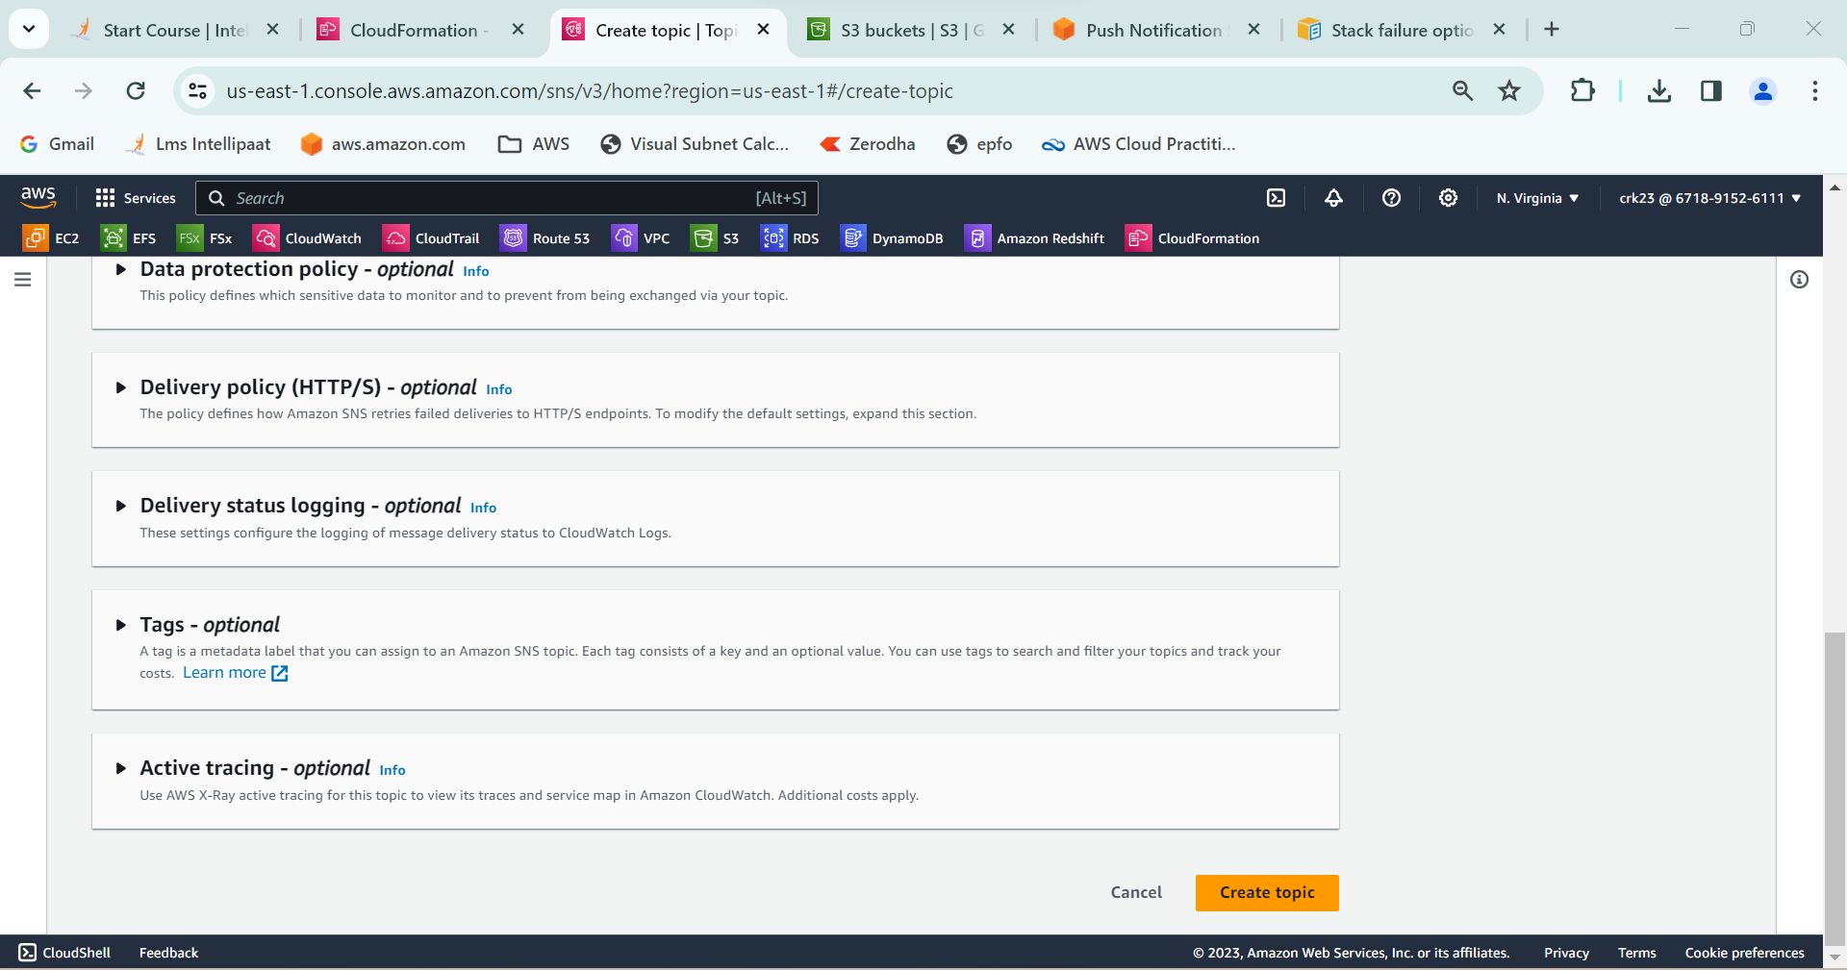

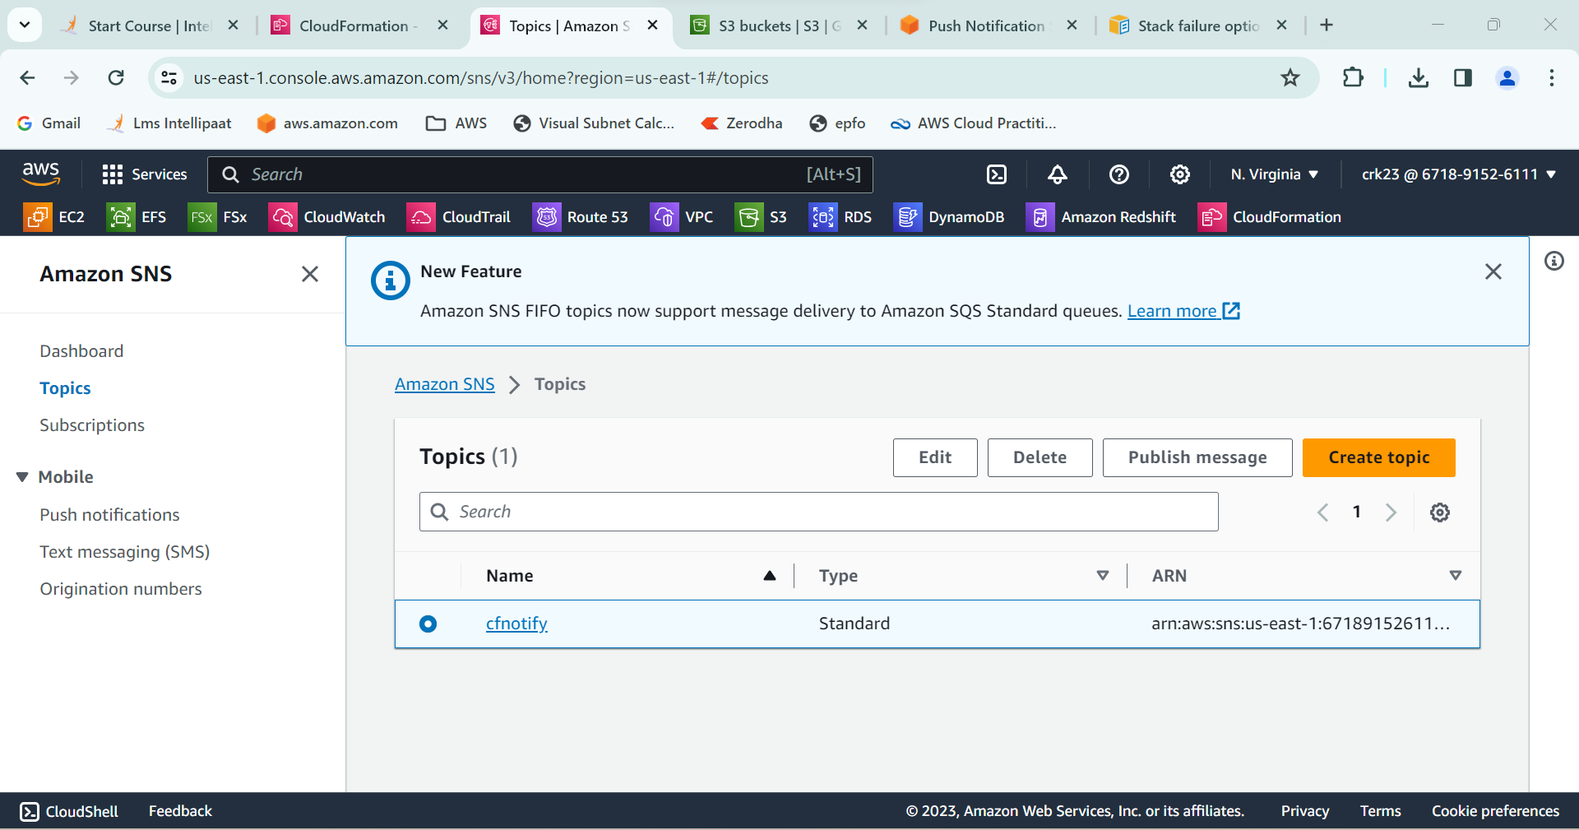

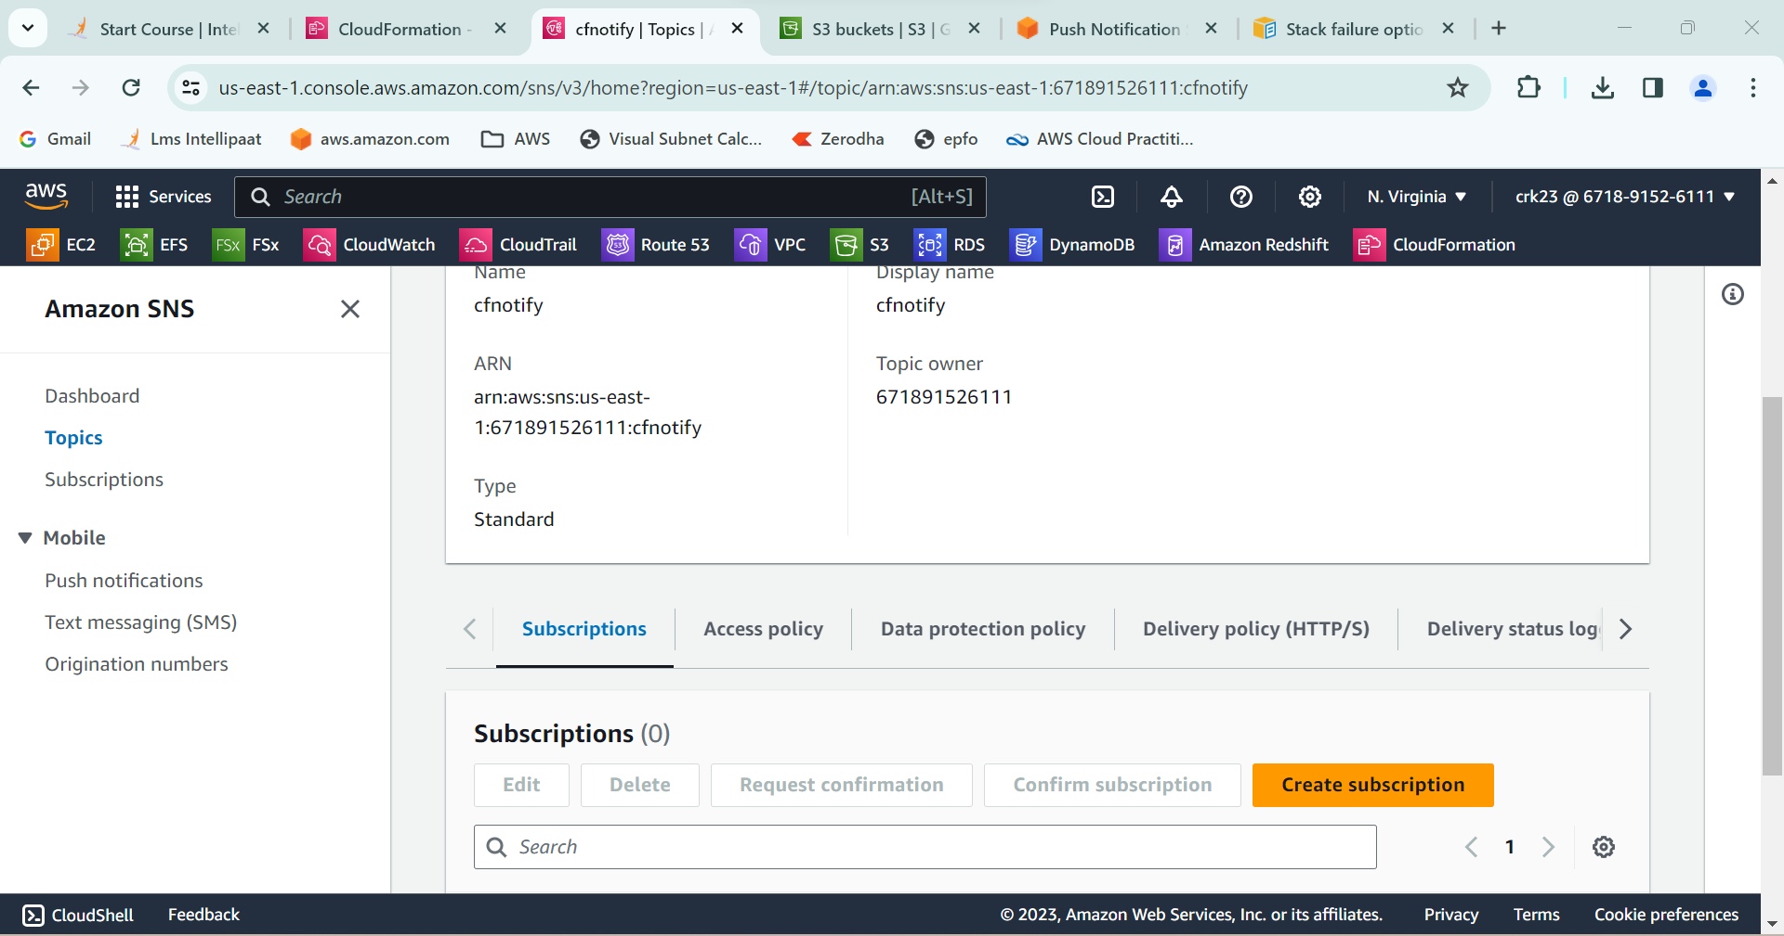

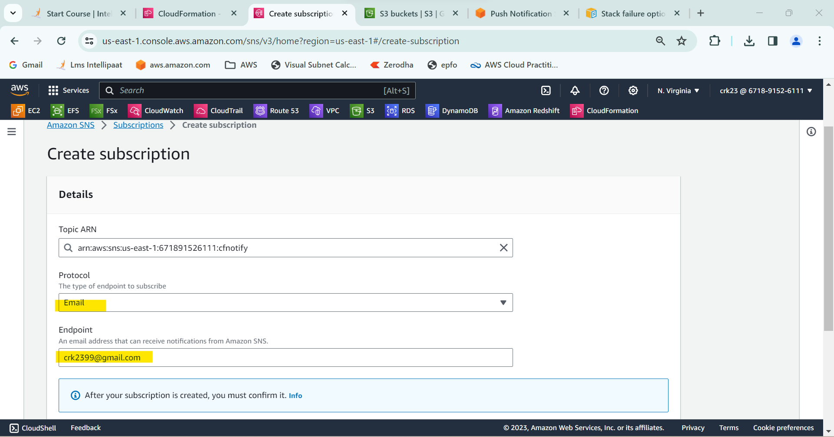

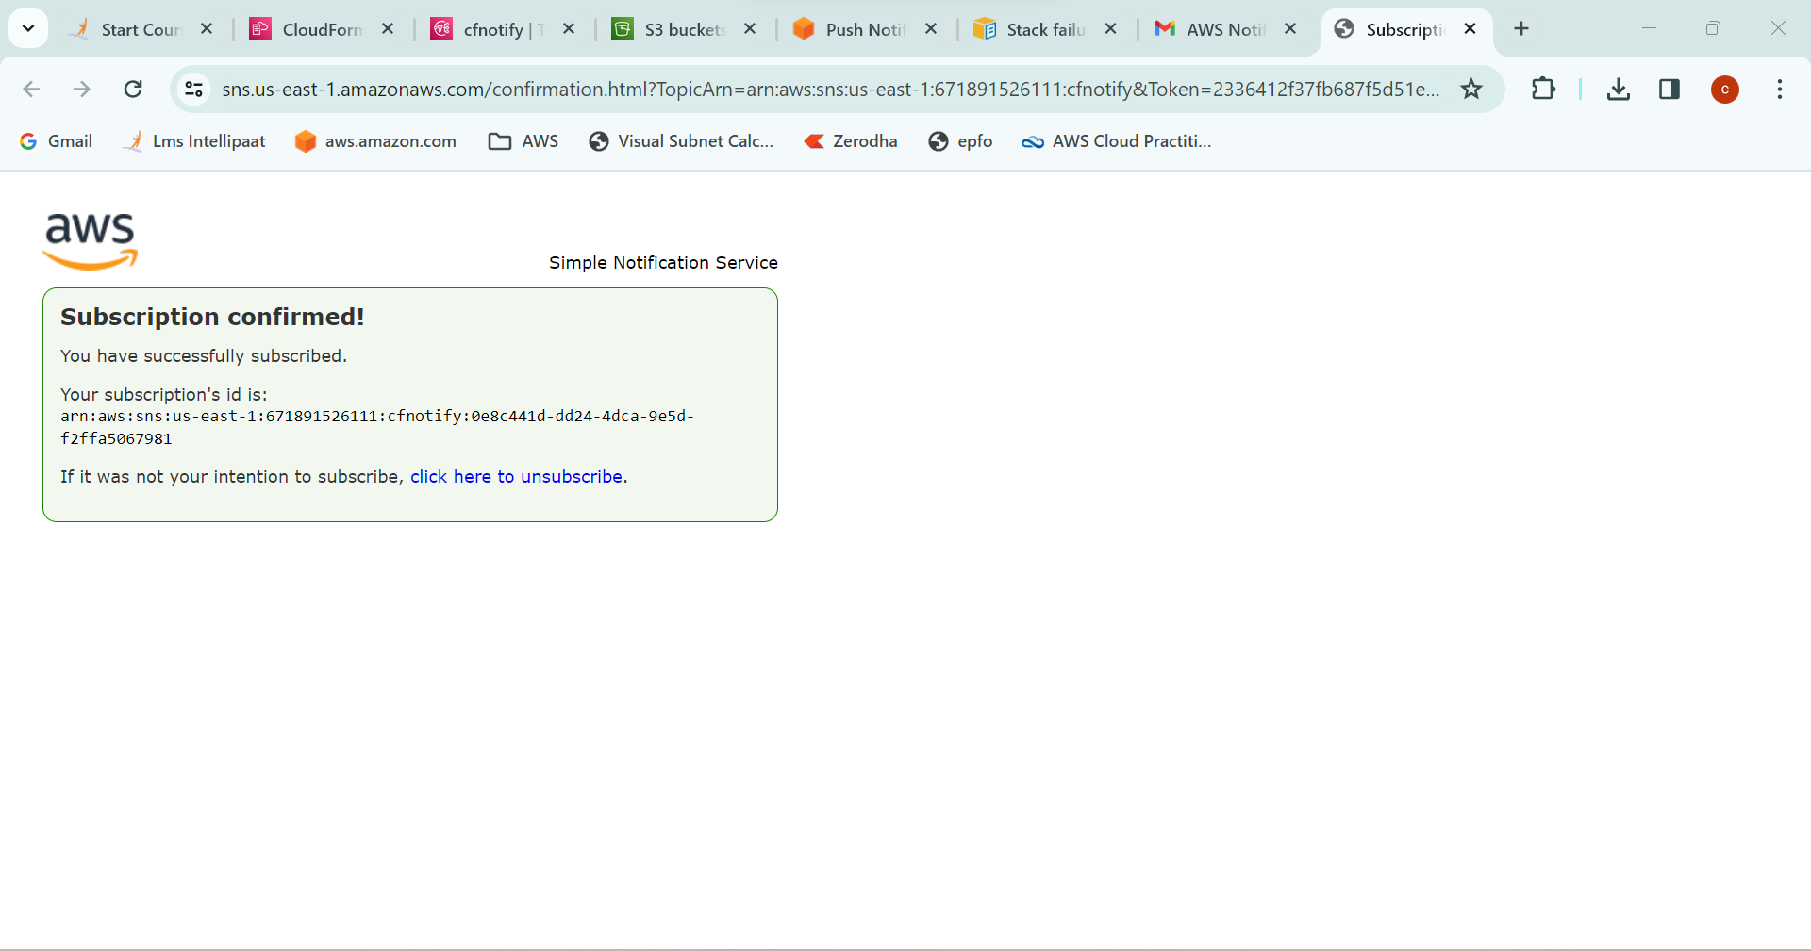

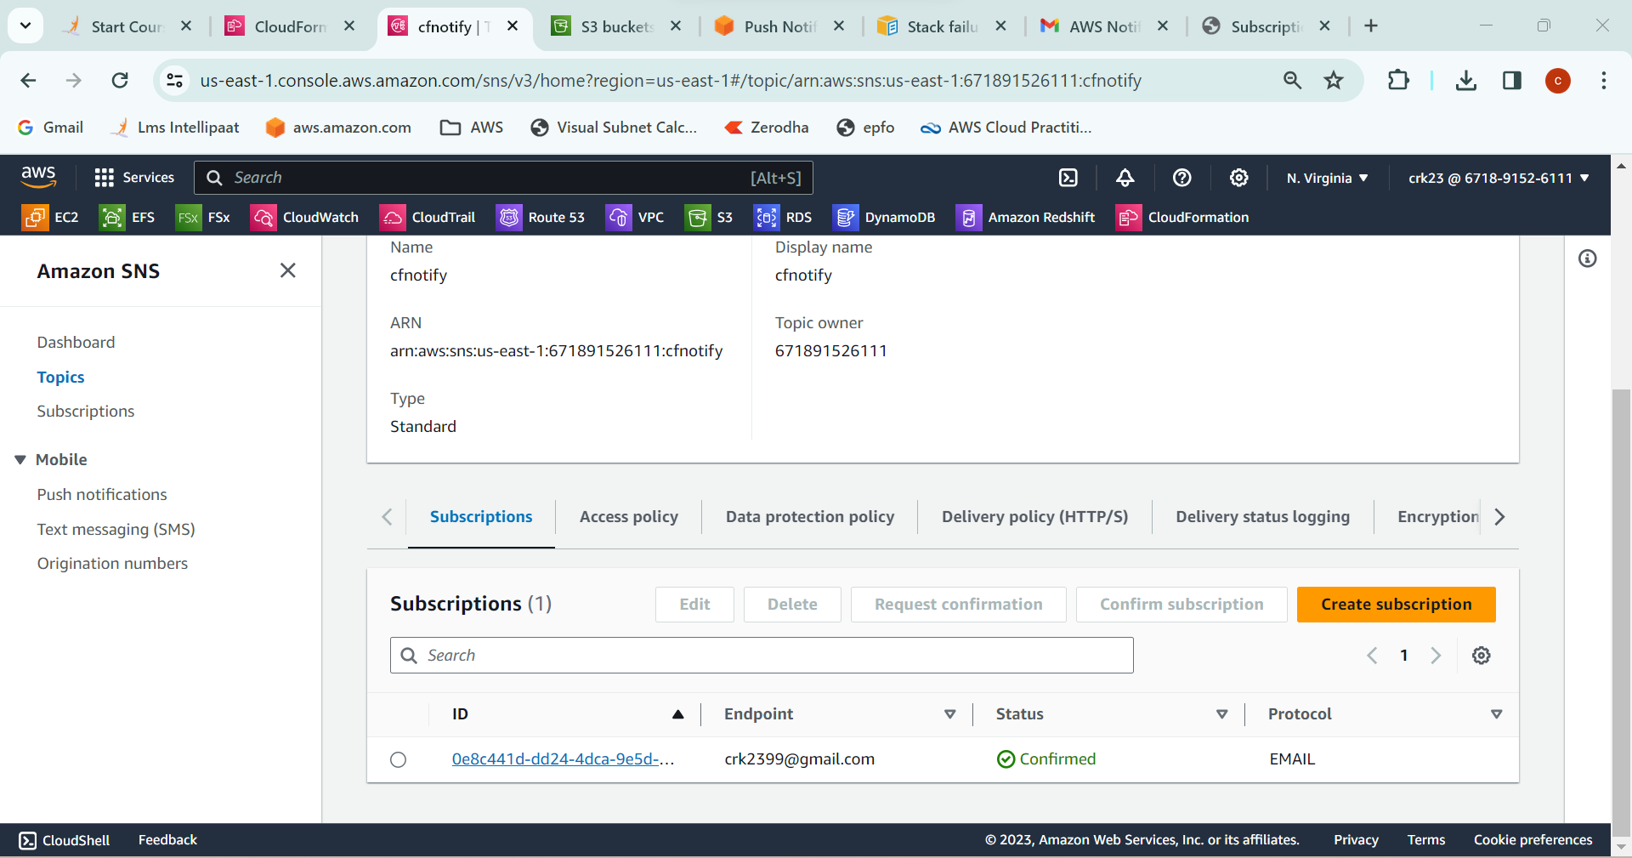

**OUTPUT:**

Used already created S3 template and added Notification to the CloudFormation stack using SNS so that you get a notification via mail for stack creation process.